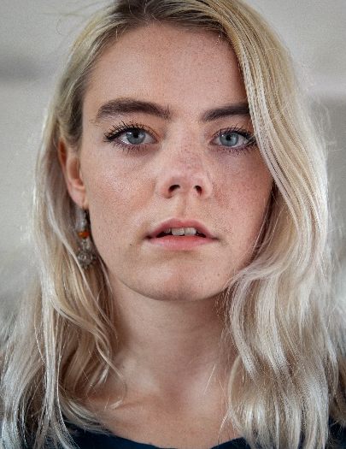
RACHEL LAIRD
07772474840 | rachellairddance@gmail.com
Rachel is an organised, empathetic, and playful performer from Scotland. She utilises her focus, articulation, and voice work to make her movement expressive and full bodied. Rachel is interested in communication and how that plays a part in society. Whether that is through movement or language. Using improvisation, physical theatre, poetry and contact work to try and relate and portray her experiences to others.
PROFESSIONAL EXPERIENCE 2020 – 2016 (In order of relevance)
Peut-Être Theatre – SHHH..Bang! and Tidy Up China Tour 2019 – 2020 (Tianjin, Nanjing and Chengdu)
English National Opera – Orphée Phillip Glass. English National Opera London Coliseum, 2019
Ròisìn O’Brien Dance (Performer and Rehearsal Director) – A Falling Ballet. Citymoves Residency Oct ’20. R&D Anatomy Rooms, Scratch Night SummerHall and Pianodrome Lunchtime sessions, Edinburgh Fringe’19.
Sliding Doors (Co-Founder and Performer) - Penthouse Hickies. Resolution Festival ‘20 The Place, Heads Up Dance Base, Ed Fringe’19 and Rising Tides Rosemary Branch Theatre, London. Residency Citymoves, Aberdeen (Feb and Aug ’20)
The Natashas Project -On Demand and Natashas. London tour
FOUND DANCE – Site Specific performances throughout Brighton as part of Our City Dances 2019 South East Dance
A Truefitt Collective - We Never Arrive. R&D London
Van Huynh Company - Under This Weight. Dance Bridges Festival. Kolkata, India.
The Yonis - #Girlswhospittogetherstaytogether Fringe’18, DanceBase Edinburgh and London Venues
Hilang Child – Good To Be Young (Music Video)
Cuckoolander - Mercury (Music Video)

PERFORMANCE EXPERIENCE
Hagit Yakira – GO. Scottish Tour
Theo Clinkard - Alert to the voices of others. Scottish Tour.
Theo TJ Lowe – He–Sha Commissioned work performed at Laban London
Martha Graham – Restaging of Panorama by Jacqueline Bulnes performed at Laban London
Heidi Rustgaard (H2 Dance) – Groups and Landscapes Commissioned work touring across London
Yael Flexer - Vortex & Re|Place (Or the thing I miss most) (NYDC Scotland) UK tour (Birmingham, Glasgow), Dublin, and India.
Matthew Robinson – Office (AD Verve/Scottish Dance Theatre). Scottish Tour.
Gavin Coward -The art of letting go. Directed by Liv Lorent. Scottish Tour
Thomas Small - BBC Radio 2 Shakespeare Shuffle. BBC Radio 2 Artists in Residence Dance Film on the London Eye.
Marc Brew – EQ Dance! Collaborative project with Edinburgh String Quartet, performed in Edinburgh

TRAINING
Copenhagen Contemporary Dance School Post Graduate Diploma Contemporary Dance
Trinity Laban Conservatoire of Music and Dance BA (HONS) Degree Contemporary Dance
Scottish School of Contemporary Dance HND Contemporary Dance

PLACEMENT
Rob Heaslip Dance FREAGRA | A Blurred Expanse
BalletLorent R&D Rumpelstiltskin and assisting family workshops at Sadler’s Wells

OTHER SKILLS AND/OR INTERESTS
Musical Theatre background, Improvisation, Contact Improvisation, Physical Theatre, Yoga, Film, Acting, Writing and Poetry.

